|  |  |
| --- | --- |
| Name | Umar Hayyat |
| Roll No | 2019-EE-360 |

**Lab 2**

**Half-wave and Full-wave Rectification**

**Objective**

## To implement a half wave rectifier.

## To implement a full-wave rectifier.

## To study the effect of filter capacitors on rectifier output.

**Half-wave Rectification**

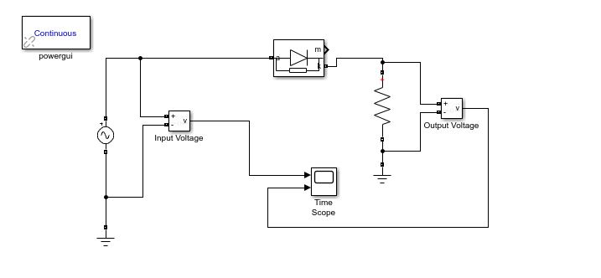

**Graph**

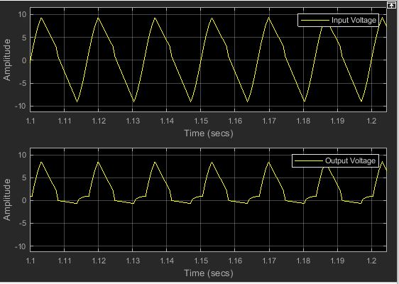

**Full wave Rectification**

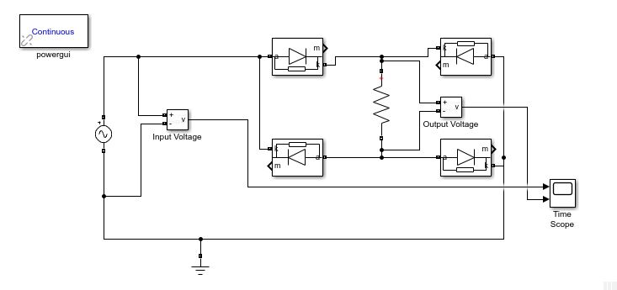

**Graph**

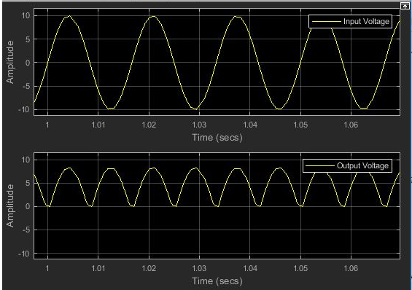

**Half wave Rectification with Capacitor**

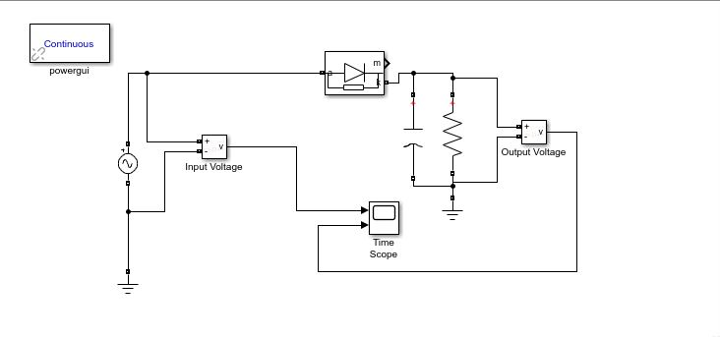

**Graph**

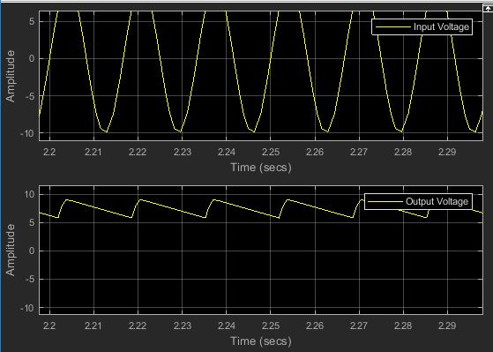

**Full wave Rectification with Capacitor**

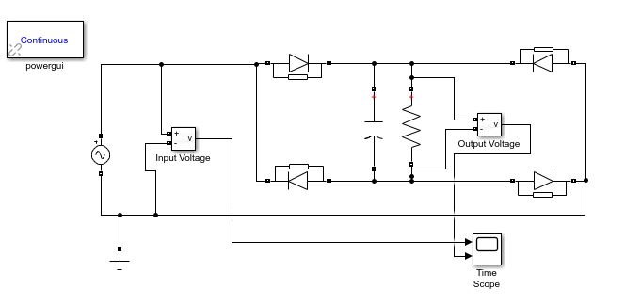

**Graph**

